Senior Year Survey will take about 3 minutes.
This is the only method to order final transcripts from Carlmont.
The survey completion is required of all seniors.
This survey will ask about your plans after June 4, 2021.
Gap year?
Community College?
4 year college?
Military?

Instructions
Log into your Naviance account
Go to About Me tab, then About me Home, click on Survey Not Started
Click on Senior Year Survey
Indicate with the pull down what your plans are after graduation (military, private college, gap year, community college etc)
In the next section - Name the colleges you applied to (if you applied), if a college is missing please add the colleges.
Under Final Decision -What did the college decide? Was it accepted, denial, waitlist etc

VERY IMPORTANT
For the college you will attend this Fall complete the 3 steps
1. Final decision use pull down to indicate Accepted
2. in the box Attending
3. in the box Send Final Transcript

See Example below

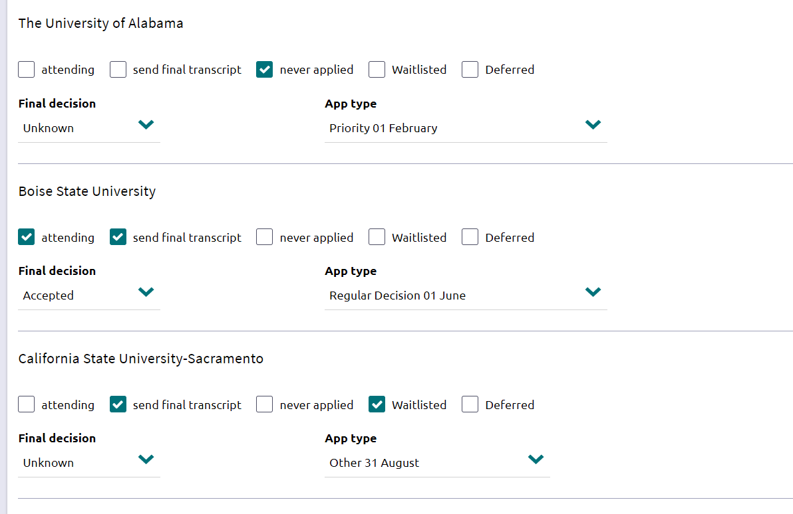

If you indicate if you have opted into a waitlist
Waitlist
Send Final Transcript
If you decided not to opt into the waitlist, then indicate Unknown under Final Decision, no need to indicate waitlist.
Question 4 and 5 might seem redundant, please complete anyway.
Please complete this survey by May 24.
Final transcripts will be sent by June 28.
If you have taken a community college course please send the transcript to your college.
Transcripts will only be sent if the Senior Year Survey is completed.

